Lab 7 Worksheet Geologic Structures
Name ______ (-2 points if missing)
Date _______
Use your textbook, lab and lecture PowerPoints, and internet as needed to answer all questions in each of the 2 parts. Please explain everything in your own words.
Part 1
- In a tensional regime, would we find more normal or more reverse faults, and why?
a.
- Would we find reverse faults in a compressional regime or tensional regime, and why?
a.
- What is the difference between a normal fault and a reverse fault?
a.
- What is the difference between anticlines and synclines?
a.
- What is the difference between in the rock unit age relationship between domes and basins?
a.
- Describe a strike slip fault. Provide an example of one.
a.
- Of the previously described structures, which are the result of brittle deformation?
a.
- Of the previously described structures, which are the result of ductile deformation?
a.
- Using the diagrams below, which of these are the result of brittle deformation?
a.
- Which of these diagrams are ductile deformation?
a.

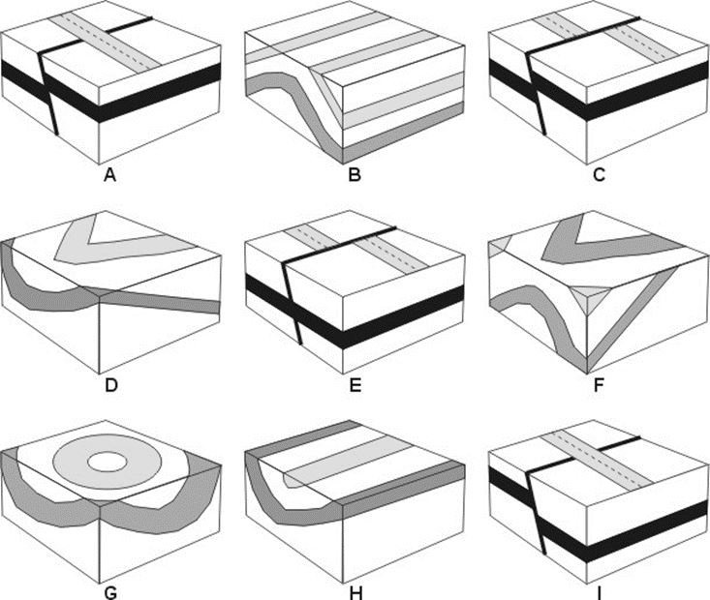

- In the diagrams above, identify each structure.

Part 2
- Matching. Use the strike and dip notation in the right column, and match each to a strike and dip symbol in the left column. Type the number in the middle column (be sure you review the lab ppt before doing this part).
 | Which number matches the diagram? | Choose from here
A |  | 1. N45E
B |  | - N60W
C |  | - N10E
D |  | - N45W
E |  | - N30W

- What type of faults are seen in the side view image below?
  - 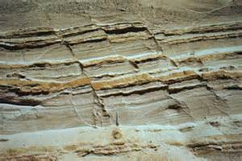

- What type of fault is seen in the side view image below?
  - 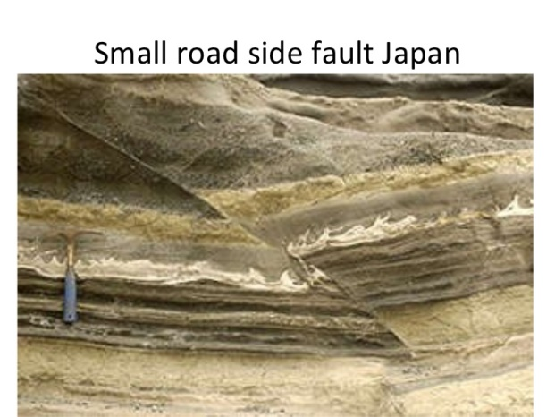

- What type of fault is seen in the aerial view below?
  - 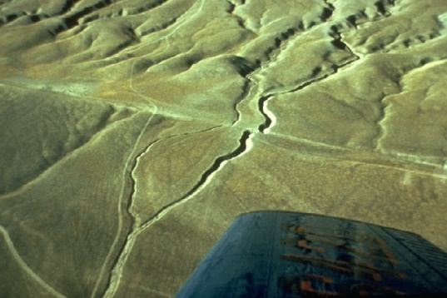

- What type of fault is shown here?
  - 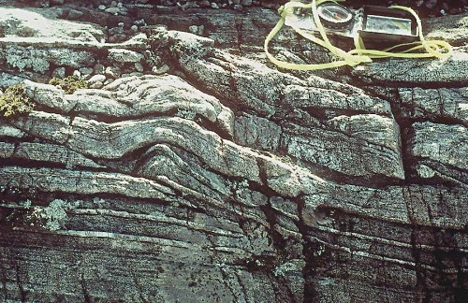

- What type of fold is this?
  - 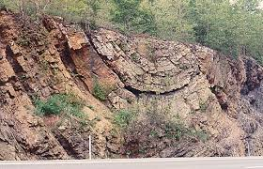

- In the image below, the greenish unit is older than the pink units. What structure is shown here?
  - 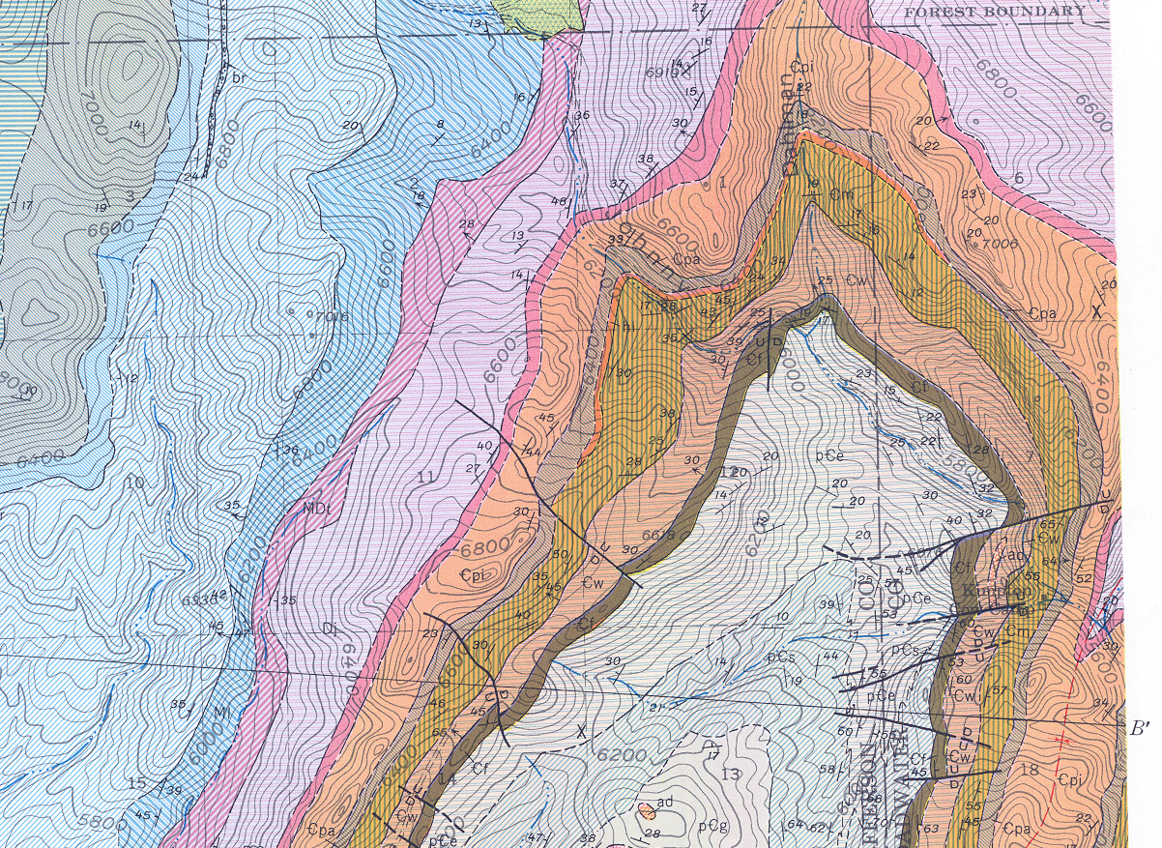

- What is a thrust fault?

- What types of places do we find multiple thrust faults?

- What map symbols is this?

